Dilute Solution and colligative properties

Solutions

Solution is a homogeneous mixture of two or more substances in same or different physical phases. The substances forming the solution are called components of the solution. On the basis of number of components a solution of two components is called binary solution.

Solute and Solvent
In a binary solution, solvent is the component which is present in large quantity while the other component is known as solute.

Classification of Solutions
(A) Following types of solutions are seen on the basis of physical state of solute and solvent.
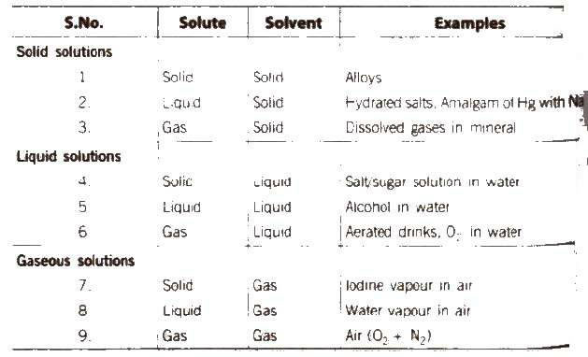
if water is used as a solvent, the solution is called aqueous solution and if not, the solution is called non-aqueous solution.
(B) Depending upon the amount of solute dissolved in a solvent we have the following types of solutions:
(i) Unsaturated solution
A solution in which more solute can be dissolved without raising temperature is called an unsaturated solution.
(ii) Saturated solution
A solution in which no solute can be dissolved further at a given temperature is called a saturated solution.

(iii) Supersaturated solution
A solution which contains more solute than that would be necessary to saturate it at a given temperature is called a supersaturated solution.

Solubility
The maximum amount of a solute that can be dissolved in a given amount of solvent (generally 100 g) at a given temperature is termed as its solubility at that temperature.
The solubility of a solute in a liquid depends upon the following factors:
(i) Nature of the solute
(ii)Nature of the solvent
(iii)Temperature of the solution
(iv) Pressure (in case of gases)

Henry’s Law
The most commonly used form of Henry‟s law states “the partial pressure (P) of the gas in vapour phase is proportional to the mole fraction (x) of the gas in the solution” and is expressed as
p = K_{H} . x
Greater the value of K_{H}, higher the solubility of the gas. The value of K_{H} decreases with increase in the temperature. Thus, aquatic species are more comfortable in cold water [more dissolved O₂] rather than Warm water.
Applications
1. In manufacture of soft drinks and soda water, CO₂ is passed at high pressure to increase its solubility.
2. To minimise the painful effects (bends) accompanying the decompression of deep sea divers. O₂ diluted with less soluble. He gas is used as breathing gas.
3. At high altitudes, the partial pressure of O₂ is less then that at the ground level. This leads to low concentrations of O₂ in the blood of climbers which causes „anoxia‟.

Concentration of Solutions
The concentration of a solution is defined as the relative amount of solute present in a solution. On the basis of concentration of solution there are two types of solutions.
- Dilute solution (ii) Concentrated solution
Methods of Expressing Concentration of Solutions
Various expression for the concentrations of solutions can be summarised as

(i) Percentage by weight
(w / w %) It is defined as the amount of solute present in 100 g of solution.
w / w % = weight of solute / weight of solution * 100

(ii) Percentage by volume
(w / V%) It is defined as the weight 01 solute present in 100 mL of solution.
w / V % = weight of solute / weight of solution * 100
or the volume of solute present in 100 mL of solution.
u / V % = volume of solute / volume of solution * 100

(iii) Mole fraction
(x) It is defined as the ratio of the number of moles of a component to the total number of moles of all the components. For a binary solution, if the number of moles of A and B are n_{A} and n_{B} respectively, the mole fraction of A will be
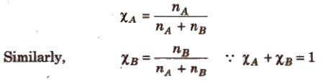
(iv) Parts per million (ppm) It is defined as the parts of a component per million parts (10⁶) of the solution. It is widely used when a solute is present in trace quantities.
ppm = number of parts of the component / total number of parts of all the components * 10⁶ (v) (v) Molarity (M) It is the number of moles of solute present in 1L(dm3) of the solution.
M = number of moles of solute / volume of solution (L)
M = mass of solute (in gram) * 1000 / mol. wt. of solute x volume of solution (in mL)
Molarity varies with temperature due to change in volume of solution.
[When molarity of a solution is 1 M, it is called a molar solution. 0.1 M solution is called a decimolar solution while 0.5 M solution is known as semi molar solution]
Molarity = Percent by mass * density * 10 / molecular weight
Dilution law, M₁ V₁ = M₂ V2 (for dilution from volume V₁ to V₂)
For reaction between two reactants, M₁ V₁ / n1 = M₂ V₂ / n₂ where, n₁ and n₂ arc stoichiometric coefficient in balanced equation.
(vi) Molality (m) It is the number of moles of solute per kilogram of the solvent.
Molality = mass of solute in gram * 1000 / mol. wt. of solute * mass of solvent (in g)
Molality is independent of temperature.
[Whcn solvent used is water, a molar (1 M) solution is more concentrated than a molal (1 M) solution.]
(vii) Normality (N) The number of gram equivalents of solute present in 1 L of solution.
Normality = number of grams – equivalent of solute / volume of solution in L
Number of gram-equivalents of solute = mass of solute in gram / equivalent weight
[Relationship between normality and molarity N x Eq. weight = M x mol. weight ]
If two solutions of the same solute having volumes and molarities V₁, M₁ and V₂, M₂ are mixed, the molarity of the resulting solution is
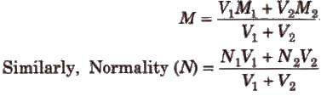
To dilute V₁ mL of a solution having molarity M₁ to molarity M₂ up to the final volume V₂ mL, the volume of water added is
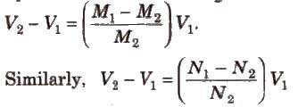
(viii) Formality (F) It is the number of formula weights of solute present per litre of the solution.
Formality = moles of substance added to solution / volume of solution (in L))
(ix) Mass fraction Mass fraction of any component in the solution is the mass of that component divided by the total mass of the solution.
Molality, mole fraction and mass fraction are preferred over molarity, normality, etc., because former involve weights which do not change with temperature.
(x) Demal (D) It represents one mole of solute present in 1L of solution at O°C.

